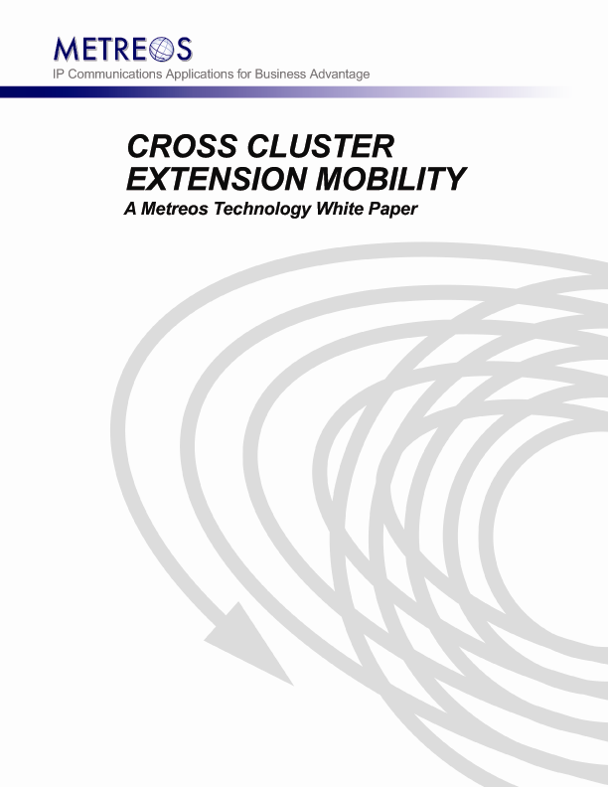

Executive Summary
As professionals become increasingly mobile in a global economy, the enterprise is faced with a new challenge: how to best provide temporary and effective office accommodations at global locations for its growing number of mobile professionals.

Optimizing physical office space usage is of course one concern, where the organization finds it now needs tools to help it utilize physical office space such that hoteling offices are available when required, while left empty as seldom as possible. The second facet of the organization's challenge is that of maximizing productivity and efficiency of the hoteling employee, by providing to as great an extent possible the convenience and facilities of the home office.

The telephone and personal computer are the centers of office activity. Computing mobility has of course been available to mobile workers for many years, but the office telephone, an equally vital means of connection to one's business contacts, has not had the ability to follow the mobile professional to temporary office quarters across town, in other cities, or countries.

Extension Mobility is the terminology for the general solution to this challenge. Extension Mobility describes the ability to move all the capabilities of one's primary office phone easily and quickly to another phone in another physical location. Ideally, the professional using an IP phone at a remote office has available the gamut of features of his or her office phone, such as voice mail, lines, phone services, and speed dials. The Cisco CallManager PBX includes Extension Mobility features usable only for deployments in which the primary phone and temporary phone are to be located on the same CallManager cluster.

Metreos provides the solution to the remaining challenge of providing truly global extension portability across CallManager clusters. This technology is Cross-Cluster Extension Mobility.

Cross-Cluster Extension Mobility Overview

What is Cross-Cluster Extension Mobility?
Cisco CallManager provides a feature known as Extension Mobility, which allows users of phones registered with the CallManager to seamlessly move the appearance, features and capabilities of their desk phone to any Cisco IP phone within the same CallManager cluster. CallManager cannot however natively provide this service across CallManager clusters.

Cross-Cluster Extension Mobility (CCEM), a Metreos Communications Environment (MCE) technology, overcomes this limitation, allowing the mobile professional to move about the world without becoming mired in the logistics of making and receiving calls using the organization’s CallManager infrastructure. On arrival at a new location, the mobile worker logs into the IP phone at the temporary office quarters. Once logged in, all calls to his primary office phone are received at the new phone. Outgoing calls likewise behave as though made from the primary phone. The CCEM application allows the mobile professional to retain her personal phone numbers, voice mail, and other features of the primary office phone, in any temporary office quarters she may occupy, spanning physical buildings, cities, and CallManager clusters

CCEM exists as an application executing within the Metreos Communications Environment runtime. As such, CCEM is easily and quickly configurable to the unique requirements of your organization, and extendable to provide any additionally features you may desire.

How does Cross-Cluster Extension Mobility Work?
In general, Cross-Cluster Extension Mobility uses a combination of Cisco CallManager APIs (AXL/SOAP, Extension Mobility, and IP Phone Services) to make dynamic phone configuration changes, in conjunction with LDAP and SQL which are used to access user attributes.

Executing an EM login across clusters requires a number of steps, each with its own unique requirements.

User Login Procedure
Using Cisco IP Phone XML Services, the mobile users initiates a CCEM login from the IP phone at the temporary office quarters. The IP phone displays for such a login are shown in Figure 1. Once the user credentials are known to the application, LDAP or SQL is used to access corporate user information, in order that the user can simultaneously be authenticated and the home cluster determined.

In the case where the hoteling phone is on the same cluster as the primary phone, the cross-cluster logic is skipped and a regular EM login is executed. If this is not the case, the CCEM application executes a cross-cluster login on the user’s behalf. Figure 2 shows the section of the application making this determination and formatting the phone display accordingly.

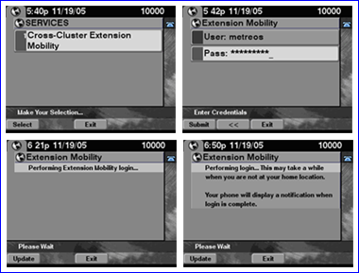
Figure 1: IP Phone Displays for CCEM Login

Activity Flow of a CCEM Login
For a user login to other than the home cluster, the following steps will occur.
- The user’s home CallManager cluster and device name are determined. Using AXL/SOAP, all pertinent data pertaining to the home IP phone is captured.
- The user’s lines, speed dials, and phone services are transferred to the current phone using the AXL/SOAP API. Any necessary translations are applied at this time to locale-specific speed dials and services in order that they make sense on the new cluster. Emergency numbers for example should be translated such that they route local within the foreign cluster.
- The calling search space of the transferred phone lines can be configured such that all outbound calls by the user go back out over an ICT destined to the home cluster. Alternatively, the calling search space could be specified such that the user’s calls are routed local to the foreign cluster.
- Voice Mail Profile is set such that voice mail is routed to the appropriate voice mail system, whether it be on the foreign or home cluster.
- A Call Forward All is set for the user’s home IP phone, configured to route across an ICT to the phone being logged into.
- The login event is recorded by CCEM. The information so stored will be accessed during user logout.

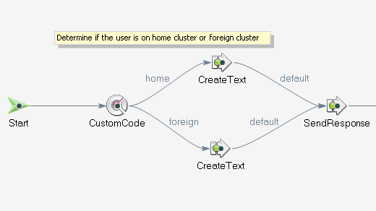
Figure 2: A Section of the CCEM Application in the Metreos Visual Designer

CCEM Behavior While Logged In
The primary focus of the CCEM application is that of enabling a user to receive calls made to his home IP phone, at the EM phone, and to make calls as he normally would. Steps taken during the login process to make this happen are:
- Call Forward All over an ICT to the foreign cluster ensures inbound calls arrive at the EM phone
- When calls originated by the user are to be routed local to the home cluster, a CSS matching the user’s access level and pre-provisioned route patterns and ICT, ensures that all calls made by the EM phone route back to the home cluster.

CCEM users should receive notification of voice mail via the phone’s Message Waiting Indicator (MWI), in addition to retaining access to their speed dials and phone services.
- CCM 4.1 and above supports inter-cluster MWI usage. CCEM will create the necessary translation pattern via AXL/SOAP to intercept and reroute MWI signals to the hoteling phone.
- Speed dials and Cisco IP Phone Services are retrieved and transferred to the hoteling phone. Translations may need to be applied to locale-specific speed dials and services.

CCEM Logout Activities
A CCEM Logout can be generated via any of the following:
- From a service on the hoteling phone
- From a service on the user’s home phone
- On a periodic configured basis
The steps taken during the cross-cluster login process are reversed to return both phones to their normal state.
- Call Forward All is removed from the user’s primary phone
- Configuration for the hoteling phone is returned to its default setting indicating that the phone is not currently hoteled.

CCEM Deployment Considerations
No generic implementation of Cross-Cluster Extension Mobility can suit a particular deployment exactly. It is expected that each organization will have specific requirements of CCEM that are not present in the shipping version. The CCEM application is designed to be quickly and easily modified by your software engineer or integrator to include such site-specific requirements. Following are some of the issues to be taken into consideration when integrating CCEM to a particular deployment:

Centralization of User Information
Ideally user information resides in one central repository and is of a uniform format. The minimum information that should be available for each user is:
- User credentials
- The device name of the user’s primary phone or the name of the user’s device profile
- The user’s home cluster

Inter-Cluster Trunk WAN/QoS Considerations
Since Call Forward All is used to route calls across an ICT for hoteling users, and since such users can potentially have all calls routed back over an ICT to their home cluster for routing, available WAN bandwidth and QoS requirements should be taken into consideration prior to making decisions on whether ICTs will be used to bridge the user to the home cluster. Alternatives do exist; such as routing the inbound Call Forward All call over the PSTN, and/or routing calls made by the hoteling user local to the foreign cluster.

Locale-Specific Speed Dials and Phone Services
Some speed dials and phone services are relevant only within a given location. Before CCEM can be applied to a particular deployment, locale-specific speed dials and services, such as emergency numbers, must be known and accounted for by the CCEM application.

Hoteled Phone Service Must Exist on Target Cluster
An AXL/SOAP restriction dictates that a Cisco IP Phone Service to be transferred to a foreign cluster hoteling phone must already exist on that cluster.

Consistency of Dialing Plan across Clusters
Ideally a uniform level of dial plan access and overall complexity exists across all CallManager clusters. When that is the case, CCEM needs only map calling search spaces and partitions between clusters.

Message Waiting Indicator (MWI) Support
CallManager 4.1 and above is required for CCEM MWI support.

CCEM Usage Rate and AXL/SOAP Throttling
Cisco does not support configuring AXL/SOAP writes or modifies on an individual CallManager cluster faster than 60 times per second. For each login and logout sequence, several such AXL/SOAP requests are executed. 60 such requests per second is the upper limit at which CCEM can perform within a single cluster.

In Summary …
Cross-Cluster Extension Mobility allows the mobile professional to use the IP telephone at their current physical location exactly as they would their primary office phone. Perhaps just as importantly, Cross-Cluster Extension Mobility frees the CallManager administrator from the necessity of accommodating a growing number of mobile users with complex and time-consuming workarounds for the extension mobility feature gap.

Finally, because the Metreos Communications Environment is a true development platform and execution engine, modifications to CCEM that are unique to a particular deployment do not require the CCEM application to be reengineered. Instead, the very framework on which CCEM is built can be used to make the necessary changes in a robust and scalable fashion with minimal effort.

